Consortium Meeting Report: Re/Presenting Europe 2024
Day 1
Research themes breakout session:

These featured discussions within a research theme. We used the critical friends’ and “active listener” methodologies in these discussions. Each working group designated a community partner or “critical friend” to guide the discussion and review ongoing work objectives and practices in the group. They were joined by an “active listener” who took notes on keywords and themes that kepy surfacing in the discussion.

Sports and Sporting Heroes: Here the discussion revolved around story-telling and the nature of a “hero.” Who gets to tell whose stories? When we designate someone a “hero” – which happens often in sports – for whom are they a hero, and what qualities are they valued for? This changes per community and it is affected by colonialism, racialization, nation-making, but also it is generational. So, the question kept surfacing – let’s check who is telling the story and what work it does. But the researchers were encouraged to keep focusing on stories, experiences, and collating knowledge about the constituent communities they serve.
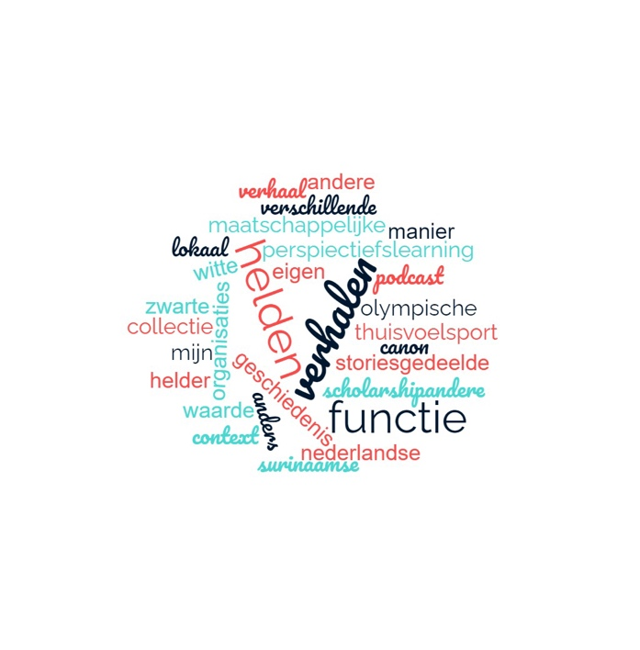

Hip Hop and Urban Arts: The central point of discussion was the creation of the first national archive of Dutch Hip-Hop. The discussion was guided by Melisa Cenik, who just recently launched De School's archive, "Het Archif," which contains over 500 DJ sets played during the club's time.

Melisa guided the session by asking critical questions about the archive, namely who it is for? Should it be a focused archive in terms of what we include? Is it meant to be educational or purely for documentation? All these questions raised some critical tensions about building such an archive regarding youth (new generation) versus OGs, the regional approach versus a national one, and gender representation and financial sustainability.

Healing, Postcolonial Trauma, and Joy: The conversations in this working group reviewed current research and outreach initiatives. One big focus, with wide societal reach, is research on the childcare scandal in 2021. The researchers are waiting for ethical clearance but once clearance is obtained, they will be producing two podcasts. The first one will be in Papamientu and will mostly be explanatory and documentary. The second podcast (2) will be interview-based and invite mothers, family members, and psychologists (in Dutch).

Two other ongoing projects engage with the archival research on narratives of Javanese people in and beyond Suriname.
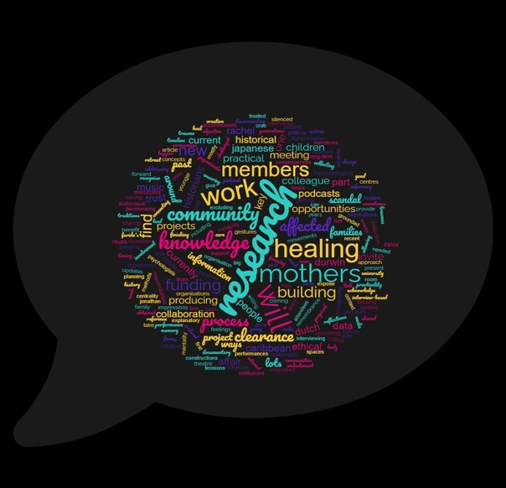

Braided Solidarities: This group tries to keep an overview of comparisons and emerging themes and practices. We were the designated “active listeners” for the other groups, employing an approach where we listened actively for recurrent themes, points of tension, and also inspiration. We went in focusing on what emerged in the conversations we observed that gives insight into the group’s objectives and where they are ‘gripping’ key concepts, moments, and societal insights. These generated keywords, for the reflection session the following day. It also generated the word clouds attached to this report and shown in our website.
Panel on the theme of new heroes:

The panel began with an engaging and fun after-movie made by Cultuur19 (as part of de Participatie Federatie) about their recent podium takeover, where young people were asked to reflect on their (new) heroes through music, theatre, dance, and art.

This panel then featured Boris van Leishout from Cultur 19, Jurryt van de Vooren director of Sportwereld, Lis Camelia, PhD student in research theme Sports, and Durwin Lynch, our Postdoc candidate on healing in the colonial afterlife.

The panelists dived into a discussion around the concept of (new) heroes, a concept highly relevant to the sports research theme. Panelists and audience alike rapidly dived into a discussion that picked up on the Sports working group questions from earlier - how we define the concept “hero”, whether heroes matter and why, and how representation comes into play. The concept of heroes, for example, could work to exclude those who do not identify (with) them.

Ultimately panelists agreed that “hero” is a useful concept and category that can be used to understand other things like nationality, community, and belonging.

Breaking & BMX Performances:

The afternoon ushered in some exciting performances, put on by TUSC (Taskforce Urban Sports and Culture). We started with a breaking demo by six breakers accompanied by a DJ on the Erasmusplein. Their skill and knowledge of body and space was inspirational and rapidly attracted and engaged an audience from the consortium and the broader University community.

The following performance was a BMX demonstration, where bunny hops, 360, and backflips were all on show. Gasps were heard! Both performances were a highlight in our programme and served as creative contribution to the program that invited us to think about different forms of knowledge and to reach beyond the lecture-room scholarly discussion that has been (perceived as) a norm in the University conference setting.

Panel reflecting on performances, urban culture and community building:

After the performances, we had a discussion reflecting on the performance with the performers and academics. They started by highlighting the importance of organisations such as TUSC as they allow people to come together to explore their passions and create knowledge about themselves and their communities, generating a sense of belonging. Farida Nabibaks spoke about the inherent value of embodied knowledge and how it is produced in coming together.

Through Farida's comments on the importance of embodied knowledge, the BMX performer ( and breakdancer start a larger conversation about how communities feel listened to once their embodied knowledge is recognised as knowledge. Indeed, knowledge about urban sports or culture cannot be attained or studied in the university's ivory tower; you need to go out and experience it. J. Griffith Rollefson echoes this by stating that the exchange of knowledge between more formal and informal institutions needs to be on an equal footing and reciprocal. Universities cannot just extract knowledge from these communities.

Day 2
Sharing methods and concepts within research themes of project:

In this session, each research group was asked to identify a single word essential for their success. The Education group highlighted terms such as "friction," "radical belonging," and "idiocultures." The Sports group emphasised "meaning-making," "stories," and "narratives." The Urban Arts group focused on "pragmatism," "practice," and "credibility." The Healing group discussed "knowledge validation," "affective/effective communication," "decolonial process," "collective archiving," and "commemoration." The WP Braided Solidarities group pinpointed "transnationalism," "coherence/coordination," and "listening." Overarching themes included "safe spaces," "recognition," "co-authorship," "visual availability," "pain," "tensions," "presence of absences," and "Black consciousness"

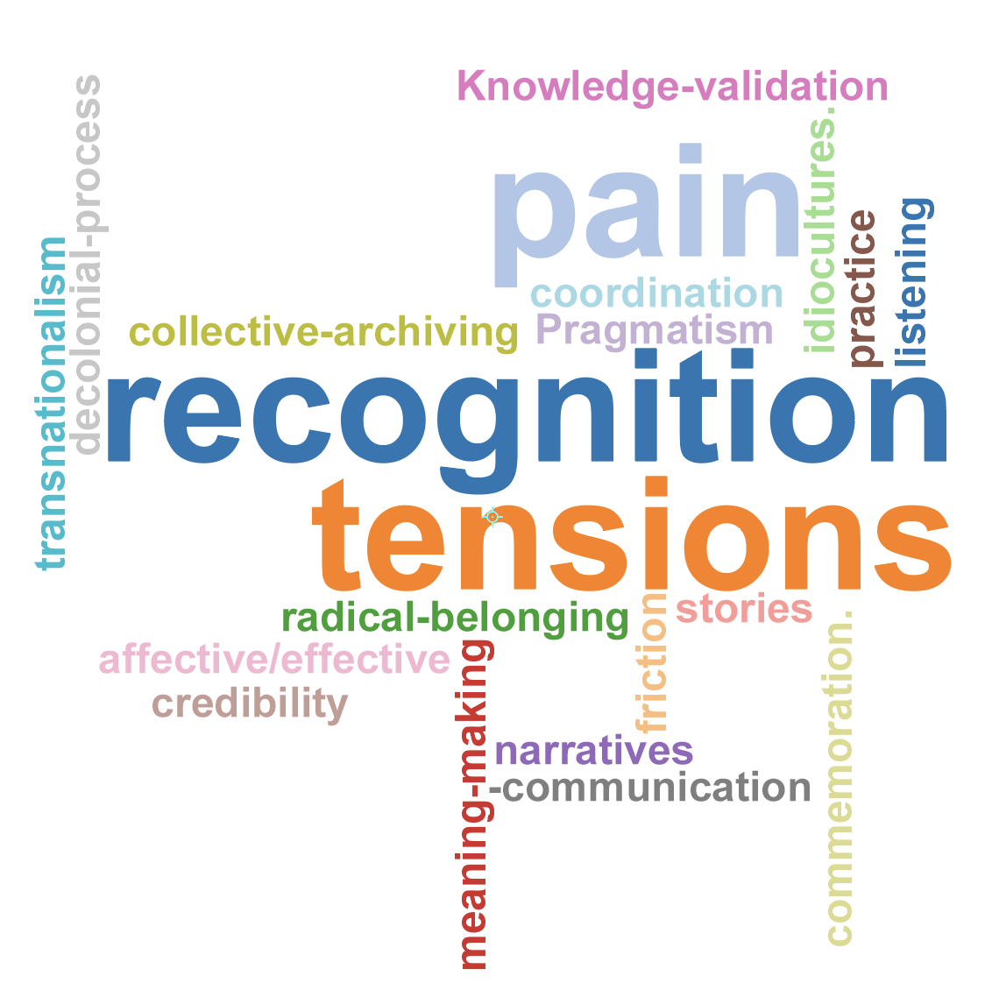

Participants also explored their methods to inspire collaboration across the various research groups. Co-authorship was identified as a key method that should be put to the forefront, also when publishing articles as a way to honour the knowledge shared by our community partners. Additionally, collective archiving, as a way to create possible moments of healing and reflexivity as a critical method.
Screening film Zwarte Ibis by Black Speaks Back:

Emma-Lee Amponsah, one of the projects Postdoc's and co-founder of Black Speaks Back, explained that the film is rooted in art-based research and emphasised that there is no singular Black experience to represent. The film aims to be a sensuous, immersive experience for the audience rather than a didactic or representative piece.

The film dras inspiration from Black cinema, including afro surrealism, Steve McQueen's "Lover's Rock," and Gabrielle Tesfaye's "The Water Will Carry Us Home. It explores the concept of portals, portraying the Black experience as fluid and evolving through time and space. It also delves into technologies that shape the Black experience. Music is vital, featuring tracks like "Sacred Sound Service" by the House of Vibration, enhancing the film's immersive quality.

Keynotes by Dr. Melanie Acosta & Prof. Kevin Hylton

Both of the keynotes were entitled "From The Pyramids, To The Ivory Tower, To Activist Scholarship: Theory, Policy, And Practice In Sport And Education".

Prof. Hylton's lecture started by stating that change is most impactful and sustainable when it happens at the institutional level and only by shifting the organisational culture at its core. By using Critical Race Theory, which emphasises the importance of the Black perspective and voice, we can advocate for thoughtful action over actionless thought that centers marginalised groups.

Dr. Acosta approached the talk more experimentally by making us do a collective reading about a myth she had written. By using the myth, she asked us to reflect on questions such as where activist work begins and what is seductive about activist scholarship in our modern institutional context

Final panel reflecting on Keynotes:

The final panel comprised our keynote lectures and three of the project's early career researchers, Zehra Çolak, Dastan Abdali, and Arne van Lienden, and moderated by Durwin Lynch. The panel's start had panellists share experiences of fluidly transitioning between community and academia, dealing with power dynamics, and justifying their roles in both spheres. They emphasised that activism begins with self-awareness and clarified the various ways to engage in activist scholarship. The discussion also questioned the true meanings and implications of terms like diversity, equity, and inclusion, considering their potential commodification. The panel concluded by debating whether to abandon or reframe these terms in ongoing conversations about inequality.

